**TCO project Blueprint**

**( Chengdu FAE P84)**

**(Song JIFENG)**

Blueprint version control:

|  |  |  |  |  |
| --- | --- | --- | --- | --- |
| Version | Date | Description of changes | Status | Approved by |
| 01 | *5/10/2016* | Creation | *Draft or Approved* | *Approver name1*  *Approver name2*  *Approver name3* |
| *02* |  |  |  |  |
| *03* |  |  |  |  |
|  |  |  |  |  |
|  |  |  |  |  |

**Table of Contents**

1 Introduction 3

2 Functional Scope 3

3 Field of application (activities covered) 4

4 Specifications 5

4.1 Introduction 5

4.2 Process and Data flow description 5

4.3 TCO Physical Layer: 5

4.4 TCO Workstation List: 6

4.5 WS10040 SMC reinforcement 7

4.6 WS10050 SMC structure cleaning 8

4.7 WS10060&61 Panel Cleaning 9

4.8 WS10070&71 Gluing(no rotating) 10

4.9 WS10080 Hinge preassembly 11

4.10 WS10090 Anti Pinch preassembly 12

4.11 WS10100 TG Loading with Harness 13

4.12 WS10120 Screws WS1 14

4.13 WS10130 Screws WS2 15

4.14 WS10140 Screws WS3 16

4.15 WS10150 Final Control 17

4.16 Matrix of diversity or BOM 18

4.17 Main TCO equipments 19

4.18 PLC communication 19

4.19 Production and container labels 20

5 Hardware architecture & Software 21

6 Questionnaire for requirements 22

# Introduction

Description of the functions necessary for “*Faurecia Chengdu FAE”* to build and delivery in sequence with Traceability and Conformity the parts requested by “*PSA*” for the “P84*”* vehicle.

*“IJCORE”* will be used to support these functions.

This document could be considered as a final agreement between GIS/TCO and the project. Project has to be informed that each change will have an impact on costs and planning.

Project has also to be informed that in serial life, changes will be quoted according to the number of added WS.

# Functional Scope

- Ensure the conformity and traceability functions during the production process, including printings of labels (semi finished goods, final labels). Functions can be different between BGs because it depends on the Process & Product and also on Conformity and Traceability rules.

FAE : Tailgates

More and more lines in a dedicated plant are sharing some commun machines. That is the case for FIS lines and plants because they are sharing injections, welding, Assy lines and some other kind of WS.

Complexe project : several lines, several shared machines, existing line(s ) shared with new line(s), new product with new process (for example project P87 tailgate in Audincourt).

A product can deliver more that one client. In this case, final label has to be printed at the end of Assy line with the right reference.

- Ensure the conformity and traceability functions during packaging and delivering, including printings of container labels (galia labels). More and more, projects ask us to also print container label and to send production declaration to MII/FCS.

During the packaging process, application will check that the parts were correctly produced (Status OK in TCO application)

case 1 : No interface with MII.

Label “OK/NOK” printed at the end of the control (produced part OK/NOK + references OK/NOK)

case 2 : Interface with MII

Label “OK/NOK” printed at the end of the control (produced part OK + references OK)

Container production declaration

case 3 : Interface with MII

Container label printed at the end of the control if the result is correct (produced part OK + references OK)

Container production declaration

- Ensure data saving and traceability (normally for 15 years but to check with client requirements). In most of current TCO applications, data are saved within database and kept during all the life of the project. Data can also be saved in a dedicated plant server.

Target is to study a solution for saving and archiving data in a centralized data base and also to share them between plants.

- Ensure reports and export of data to files (.xls, …). Target being to produced standard reports per BG. A target would be also to create these reports, directly by a central system (same system as the system used for saving and archiving data).

- Ensure input data during a downgraded mode. Several cases :

case 1 : PLC is not connected to TCO application. Operator has to scan data, TCO status will be “OK in downgrade mode”. It is a usual case and it is running.

case 2 : Missing data at a WS. Operator would have to get manually some data to the TCO system thrue an operator interface or an excel file. This point is not working yet with IJcore and it has to be taken in account.

- If a function is not covered by IT application: in this case, a RFC has to be created by IT in charge of the project.

This RFC will be analyzed by CC Brazil and approuved or rejected by EDL. As soon as it is validated by the steering committee, CC Brazil will plan a development date, according to some priorities. RFC can be followed on IJCore shareplace.

# Field of application (activities covered)

- GIS project teams will be responsible for :

- Requirements pre analysis (phase 1 and 2A of PRMS) with a RFCs management if the functions are not

covered by TCO application. During this phase, EDL will support deployment team, starting also fit gap

analysis.

- Cost Model (Services, HW and application in phase 1). Cost model will be used by the project for

approving the CAR.

- Technical specifications (Phase 2A or Blue print) with a RFCs management if the functions are not

covered by TCO application. During this phase, EDL will also support deployment team, starting also fit

gap analysis.

- Set up and tests on pre production server or environment (phase 2B)

- Pre production tests validation (phase 2B)

- Set up on production server, server preparation, deployment and preliminary tests on plant (phase 3).

Diversity matrix and BOM have to be provided by BG program team, at the latest for beginning of phase 2B

(TCO configuration).

- Preliminary tests validation (phase 3)

- Complete tests in normal (phase 3) and downgraded mode (PLC not connected to TCO)

- MPT, EMPT validations (phase 4)

- Support after phase 4

- Documents and procedures creation

- Project requirements by Project with the support of GIS/TCO

- Project flowchart by GIS/TCO

- Specifications by GIS/TCO

- TTS by GIS/ TCO (TTS /Transfert To Support)

- handover documents by GIS/TCO and Project

- Training

- Project management

# Specifications

## Introduction

For most of the projects, requirements are created by someone of the BG program team or BG TCO expert (in case of FIS). Depending of the BG, these documents can be a flowchart, a word document, …). They are created during phase 1 and they can be updated during phase 2A, according to the modifications requested by the project.

Then and as long as functions to cover and process description are not fully clear, these requirements are analyzed and discussed between project team and IT. Means also that specification can change.

When requirements are closed and validated, then IT writes technical specifications. New modifications would increase the version.

## Process and Data flow description

Technical specifications document allows to describe process and data flows. That concerns also exchanged data between PLCs and TCO application, exchanged protocols, periphericals, operations to do. This document will be updated, according to modifications (adding WS, process changes,operations changes, data changes, …). Then, exchange protocols between IT application and PLCs will be set up, according to the content of this document..

It is important to review if some functions and WS as Raw material WS, Rework WS, Packagings WS or specific WS are required because these stations are normally standard between all plants of the BG.

That is also important to review if some data exchanges are required between IT application and MII for packaging, production declarations, …). We do not have any direct exchanges between TCO application and FCS.

This document **”** **IND-TCO-CDP-Chengdu FAE P84 20160707 Process&HW”** is created during phase 2A and he has to be validated by the project team before starting phase 2B.

## TCO Physical Layer:

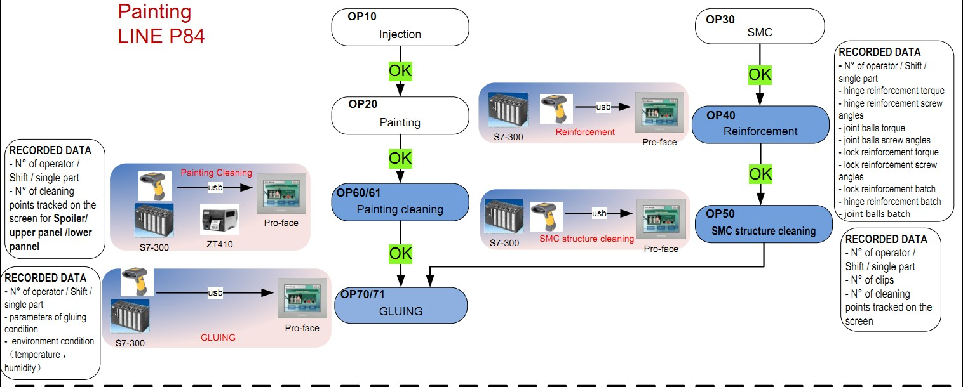

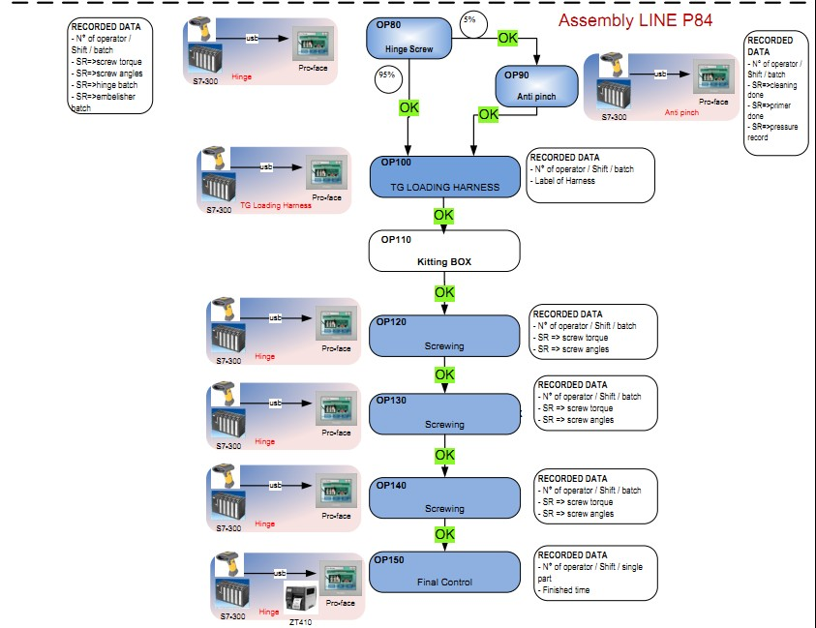

## TCO Workstation List:

|  |  |  |  |
| --- | --- | --- | --- |
| **PROJECT** | **WS Type** | **WS Quan-tity** | **WS Names** |
| Tail Gate | *Assembly* | *1* | Name: Reinforcement **WS10040** |
| Tail Gate | *Assembly* | *1* | Name: SMC Cleaning **WS10050** |
| Tail Gate | *Assembly* | *2* | Name: Panel Cleaning **WS10060&61** |
| Tail Gate | *Assembly* | *2* | Name: Gluing **WS10070 & 71** |
| Tail Gate | *Assembly* | *1* | Name: Hinge **WS10080** |
| Tail Gate | *Assembly* | *1* | Name: Anti Pinch **WS10090** |
| Tail Gate | *Assembly* | *1* | Name: TG Loading **WS10100** |
| Tail Gate | *Assembly* | *1* | Name: TG Screwing 1 **WS10120** |
| Tail Gate | *Assembly* | *1* | Name: TG Screwing 2 **WS10130** |
| Tail Gate | *Assembly* | *1* | Name: TG Screwing 3 **WS10140** |
| Tail Gate | *Assembly* | *1* | Name: Final Control **WS10150** |
|  | *Total WS* | *13* |  |

## WS10040 SMC reinforcement

***4.5.1 Production process***

Production process will be controlled at this workstation by Pokayoke-Restrictions and done by process specifications as follow-ing:

1. Read the Worker ID,Shift

2. Read the part to be produce (TG Kanban) + SMC label

3. TCO send conformity OK or NOK

4. If conformity is OK, Operator starts the process.

5. The machine process ends with OK or FAIL result.

Read the lock reinforcement,hinge reinforcement and joint ball batch number for each new batch.

***4.5.2 Conformity***

Operation is not repeatable for OK and NOK part.

***4.5.3 fTCO-PLC communication***

*Standard interchange protocol AUS-12/10/23-10-EN (machine with 1 station) will be used between fTCO and PLC:*

|  |  |  |  |
| --- | --- | --- | --- |
| **Description (TCO -> PLC)** | **Address** | **Format** | **Name** |
| Bit of life network | **DBxxx.DBX0.0** | **Boolean** | TCO_Bit_of_Life |
| Cycle Authorization | **DBxxx.DBX0.1** | **Boolean** | TCO_Enable_Cycle |
| Left part | **DBxxx.DBX0.2** | **Boolean** | TCO_Left_part |
| Right part | **DBxxx.DBX0.3** | **Boolean** | TCO_Right_part |
| Traceability system ON/OFF | **DBxxx.DBX0.4** | **Boolean** | TCO_with_PLC |
| Product Version | **DBxxx.DBW2** | **Integer** | TCO_Product_version |
| **Description (PLC -> TCO)** | **Format** | **Format** | **Name** |
| Bit of life network | **DBxxx.DBX10.0** | **Boolean** | PLC_Bit_of_Life |
| End of cycle OK | **DBxxx.DBX10.1** | **Boolean** | PLC_Cycle_OK |
| End of cycle NOK | **DBxxx.DBX10.2** | **Boolean** | PLC_Cycle_NOK |
| Cycle machine in progress | **DBxxx.DBX10.3** | **Boolean** | PLC_Cycle_Run |
| Machine traceability function ON/OFF | **DBxxx.DBX10.4** | **Boolean** | PLC_with_TCO |
| Machine ready to run in the automatic mode | **DBxxx.DBX105** | **Boolean** | PLC_Ready |
| Production Version | **DBxxx.DBW12** | **Integer** | PLC_Production_version |
| Process parameters | **DBxxx.DBW14** | **Word (s)** | PLC_Process_parameters |

***4.5.4 Labels***

No label printed in this workstation.

***4.5.5 Hardware***

At this Workstation the following Hardware will be connected to fTCO System:

* + - Barcode Reader Motorola Symbol, reference DS3578,
    - Proface,
    - Traceability box,
    - Siemens S7-300 - AUS-12/10/23-10-EN Section 1 (ISCP1 with Ethernet card).
    - No Printer.

***4.5.6 Process parameters to be traced***

* *Date & Time System.*
* *Status of end of cycle.*
* *Worker.*
* *Torque and Angel for lock,joint ball and reinforcement.*

## WS10050 SMC structure cleaning

***4.6.1 Production process***

Production process will be controlled at this workstation by Pokayoke-Restrictions and done by process specifications as follow-ing:

1. Read the Worker ID, Shift

2. Read the label of SMC

3. TCO send conformity OK or NOK

4. If conformity is OK, Operator starts the process.

5. The machine process ends with OK or FAIL result.

***4.6.2 Conformity***

Operation is not repeatable for OK and NOK part.

WS10040 is OK.

***4.6.3 fTCO-PLC communication***

*Standard interchange protocol AUS-12/10/23-10-EN (machine with 1 station) will be used between fTCO and PLC:*

|  |  |  |  |
| --- | --- | --- | --- |
| **Description (TCO -> PLC)** | **Address** | **Format** | **Name** |
| Bit of life network | **DBxxx.DBX0.0** | **Boolean** | TCO_Bit_of_Life |
| Cycle Authorization | **DBxxx.DBX0.1** | **Boolean** | TCO_Enable_Cycle |
| Left part | **DBxxx.DBX0.2** | **Boolean** | TCO_Left_part |
| Right part | **DBxxx.DBX0.3** | **Boolean** | TCO_Right_part |
| Traceability system ON/OFF | **DBxxx.DBX0.4** | **Boolean** | TCO_with_PLC |
| Product Version | **DBxxx.DBW2** | **Integer** | TCO_Product_version |
| **Description (PLC -> TCO)** | **Format** | **Format** | **Name** |
| Bit of life network | **DBxxx.DBX10.0** | **Boolean** | PLC_Bit_of_Life |
| End of cycle OK | **DBxxx.DBX10.1** | **Boolean** | PLC_Cycle_OK |
| End of cycle NOK | **DBxxx.DBX10.2** | **Boolean** | PLC_Cycle_NOK |
| Cycle machine in progress | **DBxxx.DBX10.3** | **Boolean** | PLC_Cycle_Run |
| Machine traceability function ON/OFF | **DBxxx.DBX10.4** | **Boolean** | PLC_with_TCO |
| Machine ready to run in the automatic mode | **DBxxx.DBX105** | **Boolean** | PLC_Ready |
| Production Version | **DBxxx.DBW12** | **Integer** | PLC_Production_version |
| Process parameters | **DBxxx.DBW14** | **Word (s)** | PLC_Process_parameters |

***4.6.4 Labels***

label printed in this workstation.

***4.6.5 Hardware***

At this Workstation the following Hardware will be connected to fTCO System:

* + - Barcode Reader Motorola Symbol, reference DS3578
    - Proface,
    - Traceability box,
    - Siemens S7-300 - AUS-12/10/23-10-EN Section 1 (ISCP1 with Ethernet card).
    - Printer ZT410.

***4.6.6 Process parameters to be traced***

* *Date & Time System.*
* *Status of end of cycle.*
* *Worker.*
* *Parameters of cleaning points.*

## WS10060&61 Panel Cleaning

***4.7.1 Production process***

Production process will be controlled at this workstation by Pokayoke-Restrictions and done by process specifications as follow-ing:

WS10060:

1. Read the Worker ID,Shift

2. Read the Kanban of Panel(Panel Type)

2. Read the label of upper Panel or lower Panel at WS10060

3. TCO send conformity OK or NOK

4. If conformity is OK, Operator starts the process.

5. The machine process ends with OK or FAIL result.

WS10061:

1. Read the Worker ID, Shift

2. Read the Kanban of Panel.

3. Read the label of spoiler Label at WS10061

4. TCO send conformity OK or NOK

5. If conformity is OK, Operator starts the process.

6. The machine process ends with OK or FAIL result.

***4.7.2 Conformity***

Operation is not repeatable for OK and NOK part.

***4.7.3 fTCO-PLC communication***

*Standard interchange protocol AUS-12/10/23-10-EN (machine with 1 station) will be used between fTCO and PLC:*

|  |  |  |  |
| --- | --- | --- | --- |
| **Description (TCO -> PLC)** | **Address** | **Format** | **Name** |
| Bit of life network | **DBxxx.DBX0.0** | **Boolean** | TCO_Bit_of_Life |
| Cycle Authorization | **DBxxx.DBX0.1** | **Boolean** | TCO_Enable_Cycle |
| Left part | **DBxxx.DBX0.2** | **Boolean** | TCO_Left_part |
| Right part | **DBxxx.DBX0.3** | **Boolean** | TCO_Right_part |
| Traceability system ON/OFF | **DBxxx.DBX0.4** | **Boolean** | TCO_with_PLC |
| Product Version | **DBxxx.DBW2** | **Integer** | TCO_Product_version |
| **Description (PLC -> TCO)** | **Format** | **Format** | **Name** |
| Bit of life network | **DBxxx.DBX10.0** | **Boolean** | PLC_Bit_of_Life |
| End of cycle OK | **DBxxx.DBX10.1** | **Boolean** | PLC_Cycle_OK |
| End of cycle NOK | **DBxxx.DBX10.2** | **Boolean** | PLC_Cycle_NOK |
| Cycle machine in progress | **DBxxx.DBX10.3** | **Boolean** | PLC_Cycle_Run |
| Machine traceability function ON/OFF | **DBxxx.DBX10.4** | **Boolean** | PLC_with_TCO |
| Machine ready to run in the automatic mode | **DBxxx.DBX105** | **Boolean** | PLC_Ready |
| Production Version | **DBxxx.DBW12** | **Integer** | PLC_Production_version |
| Process parameters | **DBxxx.DBW14** | **Word (s)** | PLC_Process_parameters |

***4.7.4 Labels***

label printed in this workstation.

***4.7.5 Hardware***

At this Workstation the following Hardware will be connected to fTCO System:

* + - Barcode Reader Motorola Symbol, reference DS3578
    - Proface,
    - Traceability box,
    - Siemens S7-300 - AUS-12/10/23-10-EN Section 1 (ISCP1 with Ethernet card).
    - Printer ZT410.

***4.7.6 Process parameters to be traced***

* *Date & Time System.*
* *Status of end of cycle.*
* *Worker.*
* *Parameters of cleaning points.*

## WS10070&71 Gluing(no rotating)

***4.8.1 Production process***

Production process will be controlled at this workstation by Pokayoke-Restrictions and done by process specifications as follow-ing:

WS10070:

1. Read the Worker ID,

2. Read the label of upper Panel,lower Panel ,spoiler label at WS10070

3. Read NFP label(Extenal Label).

3. TCO send conformity OK or NOK

4. If conformity is OK, Operator starts the process.

5. The machine process ends with OK or FAIL result.

WS10071:

1. Read the Worker ID,

2. Read the label of SMC Label at WS10071

3. Read NFP label(Extenal Label).

3. TCO send conformity OK or NOK.

4. If conformity is OK, Operator starts the process.

5. The machine process ends with OK or FAIL result.

***4.8.2 Conformity***

Operation is not repeatable for OK and NOK part.

WS10060/61 is OK.

***4.8.3 fTCO-PLC communication***

*Standard interchange protocol AUS-12/10/23-10-EN (machine with 1 station) will be used between fTCO and PLC:*

|  |  |  |  |
| --- | --- | --- | --- |
| **Description (TCO -> PLC)** | **Address** | **Format** | **Name** |
| Bit of life network | **DBxxx.DBX0.0** | **Boolean** | TCO_Bit_of_Life |
| Cycle Authorization | **DBxxx.DBX0.1** | **Boolean** | TCO_Enable_Cycle |
| Left part | **DBxxx.DBX0.2** | **Boolean** | TCO_Left_part |
| Right part | **DBxxx.DBX0.3** | **Boolean** | TCO_Right_part |
| Traceability system ON/OFF | **DBxxx.DBX0.4** | **Boolean** | TCO_with_PLC |
| Product Version | **DBxxx.DBW2** | **Integer** | TCO_Product_version |
| **Description (PLC -> TCO)** | **Format** | **Format** | **Name** |
| Bit of life network | **DBxxx.DBX10.0** | **Boolean** | PLC_Bit_of_Life |
| End of cycle OK | **DBxxx.DBX10.1** | **Boolean** | PLC_Cycle_OK |
| End of cycle NOK | **DBxxx.DBX10.2** | **Boolean** | PLC_Cycle_NOK |
| Cycle machine in progress | **DBxxx.DBX10.3** | **Boolean** | PLC_Cycle_Run |
| Machine traceability function ON/OFF | **DBxxx.DBX10.4** | **Boolean** | PLC_with_TCO |
| Machine ready to run in the automatic mode | **DBxxx.DBX105** | **Boolean** | PLC_Ready |
| Production Version | **DBxxx.DBW12** | **Integer** | PLC_Production_version |
| Process parameters | **DBxxx.DBW14** | **Word (s)** | PLC_Process_parameters |

***4.8.4 Labels***

NO label printed in this workstation.

***4.8.5 Hardware***

At this Workstation the following Hardware will be connected to fTCO System:

* + - Barcode Reader Motorola Symbol, reference DS3578
    - Proface,
    - Traceability box,
    - Siemens S7-300 - AUS-12/10/23-10-EN Section 1 (ISCP1 with Ethernet card).
    - NO Printer

***4.8.6 Process parameters to be traced***

* *Date & Time System.*
* *Status of end of cycle.*
* *Worker.*
* *Parameters of Gluing.*

## WS10080 Hinge preassembly

***4.9.1 Production process***

Production process will be controlled at this workstation by Pokayoke-Restrictions and done by process specifications as follow-ing:

1. Read the Worker ID, Shift

2. Read the part to be produce (TG Kanban)

3. Read SMC Label

4. TCO send conformity OK or NOK

5. If conformity is OK, Operator starts the process.

6. The machine process ends with OK or FAIL result.

Read the hinge and embelisher batch number for each new batch.

***4.9.2 Conformity***

Operation is not repeatable for OK and NOK part.

WS10070/71 is OK.

***4.9.3 fTCO-PLC communication***

*Standard interchange protocol AUS-12/10/23-10-EN (machine with 1 station) will be used between fTCO and PLC:*

|  |  |  |  |
| --- | --- | --- | --- |
| **Description (TCO -> PLC)** | **Address** | **Format** | **Name** |
| Bit of life network | **DBxxx.DBX0.0** | **Boolean** | TCO_Bit_of_Life |
| Cycle Authorization | **DBxxx.DBX0.1** | **Boolean** | TCO_Enable_Cycle |
| Left part | **DBxxx.DBX0.2** | **Boolean** | TCO_Left_part |
| Right part | **DBxxx.DBX0.3** | **Boolean** | TCO_Right_part |
| Traceability system ON/OFF | **DBxxx.DBX0.4** | **Boolean** | TCO_with_PLC |
| Product Version | **DBxxx.DBW2** | **Integer** | TCO_Product_version |
| **Description (PLC -> TCO)** | **Format** | **Format** | **Name** |
| Bit of life network | **DBxxx.DBX10.0** | **Boolean** | PLC_Bit_of_Life |
| End of cycle OK | **DBxxx.DBX10.1** | **Boolean** | PLC_Cycle_OK |
| End of cycle NOK | **DBxxx.DBX10.2** | **Boolean** | PLC_Cycle_NOK |
| Cycle machine in progress | **DBxxx.DBX10.3** | **Boolean** | PLC_Cycle_Run |
| Machine traceability function ON/OFF | **DBxxx.DBX10.4** | **Boolean** | PLC_with_TCO |
| Machine ready to run in the automatic mode | **DBxxx.DBX105** | **Boolean** | PLC_Ready |
| Production Version | **DBxxx.DBW12** | **Integer** | PLC_Production_version |
| Process parameters | **DBxxx.DBW14** | **Word (s)** | PLC_Process_parameters |

***4.9.4 Labels***

No label printed in this workstation.

***4.9.5 Hardware***

At this Workstation the following Hardware will be connected to fTCO System:

* + - Barcode Reader Motorola Symbol, reference DS3578,
    - Proface,
    - Traceability box,
    - Siemens S7-300 - AUS-12/10/23-10-EN Section 1 (ISCP1 with Ethernet card).
    - No Printer.

***4.9.6 Process parameters to be traced***

* *Date & Time System.*
* *Status of end of cycle.*
* *Worker.*
* *Torque and Angel for hine.*

## WS10090 Anti Pinch preassembly

***4.10.1 Production process***

Production process will be controlled at this workstation by Pokayoke-Restrictions and done by process specifications as follow-ing:

1. Read the Worker ID,

2. Read the label of SMC

3. TCO send conformity OK or NOK

4. If conformity is OK, Operator starts the process.

5. The machine process ends with OK or FAIL result.

***4.10.2 Conformity***

Control only the Anti Version need operate on this WS.

WS10080 is OK.

Operation is not repeatable for OK and NOK part.

***4.10.3 fTCO-PLC communication***

*Standard interchange protocol AUS-12/10/23-10-EN (machine with 1 station) will be used between fTCO and PLC:*

|  |  |  |  |
| --- | --- | --- | --- |
| **Description (TCO -> PLC)** | **Address** | **Format** | **Name** |
| Bit of life network | **DBxxx.DBX0.0** | **Boolean** | TCO_Bit_of_Life |
| Cycle Authorization | **DBxxx.DBX0.1** | **Boolean** | TCO_Enable_Cycle |
| Left part | **DBxxx.DBX0.2** | **Boolean** | TCO_Left_part |
| Right part | **DBxxx.DBX0.3** | **Boolean** | TCO_Right_part |
| Traceability system ON/OFF | **DBxxx.DBX0.4** | **Boolean** | TCO_with_PLC |
| Product Version | **DBxxx.DBW2** | **Integer** | TCO_Product_version |
| **Description (PLC -> TCO)** | **Format** | **Format** | **Name** |
| Bit of life network | **DBxxx.DBX10.0** | **Boolean** | PLC_Bit_of_Life |
| End of cycle OK | **DBxxx.DBX10.1** | **Boolean** | PLC_Cycle_OK |
| End of cycle NOK | **DBxxx.DBX10.2** | **Boolean** | PLC_Cycle_NOK |
| Cycle machine in progress | **DBxxx.DBX10.3** | **Boolean** | PLC_Cycle_Run |
| Machine traceability function ON/OFF | **DBxxx.DBX10.4** | **Boolean** | PLC_with_TCO |
| Machine ready to run in the automatic mode | **DBxxx.DBX105** | **Boolean** | PLC_Ready |
| Production Version | **DBxxx.DBW12** | **Integer** | PLC_Production_version |
| Process parameters | **DBxxx.DBW14** | **Word (s)** | PLC_Process_parameters |

***4.10.4 Labels***

NO label printed in this workstation.

***4.10.5 Hardware***

At this Workstation the following Hardware will be connected to fTCO System:

* + - Barcode Reader Motorola Symbol, reference DS3578
    - Proface,
    - Traceability box,
    - Siemens S7-300 - AUS-12/10/23-10-EN Section 1 (ISCP1 with Ethernet card).
    - NO Printer.

***4.10.6 Process parameters to be traced***

* *Date & Time System.*
* *Status of end of cycle.*
* *Worker.*
* *Parameters of pressure.*

## WS10100 TG Loading with Harness

***4.11.1 Production process***

Production process will be controlled at this workstation by Pokayoke-Restrictions and done by process specifications as follow-ing:

1. Read the Worker ID,

2. Read the Production Order label

3. Read the SMC Label

3. TCO send conformity OK or NOK

4. If conformity is OK, Operator starts the process.

5. The machine process ends with OK or FAIL result.

***4.11.2 Conformity***

Control the SMC Version done on Pre WS.

Normal Version : WS10080 is OK.

Anti Version : WS10090 is OK.

Operation is not repeatable for OK and NOK part.

***4.11.3 fTCO-PLC communication***

*Standard interchange protocol AUS-12/10/23-10-EN (machine with 1 station) will be used between fTCO and PLC:*

|  |  |  |  |
| --- | --- | --- | --- |
| **Description (TCO -> PLC)** | **Address** | **Format** | **Name** |
| Bit of life network | **DBxxx.DBX0.0** | **Boolean** | TCO_Bit_of_Life |
| Cycle Authorization | **DBxxx.DBX0.1** | **Boolean** | TCO_Enable_Cycle |
| Left part | **DBxxx.DBX0.2** | **Boolean** | TCO_Left_part |
| Right part | **DBxxx.DBX0.3** | **Boolean** | TCO_Right_part |
| Traceability system ON/OFF | **DBxxx.DBX0.4** | **Boolean** | TCO_with_PLC |
| Product Version | **DBxxx.DBW2** | **Integer** | TCO_Product_version |
| **Description (PLC -> TCO)** | **Format** | **Format** | **Name** |
| Bit of life network | **DBxxx.DBX10.0** | **Boolean** | PLC_Bit_of_Life |
| End of cycle OK | **DBxxx.DBX10.1** | **Boolean** | PLC_Cycle_OK |
| End of cycle NOK | **DBxxx.DBX10.2** | **Boolean** | PLC_Cycle_NOK |
| Cycle machine in progress | **DBxxx.DBX10.3** | **Boolean** | PLC_Cycle_Run |
| Machine traceability function ON/OFF | **DBxxx.DBX10.4** | **Boolean** | PLC_with_TCO |
| Machine ready to run in the automatic mode | **DBxxx.DBX105** | **Boolean** | PLC_Ready |
| Production Version | **DBxxx.DBW12** | **Integer** | PLC_Production_version |
| Process parameters | **DBxxx.DBW14** | **Word (s)** | PLC_Process_parameters |

***4.11.4 Labels***

NO label printed in this workstation.

***4.11.5 Hardware***

At this Workstation the following Hardware will be connected to fTCO System:

* + - Barcode Reader Motorola Symbol, reference DS3578
    - Proface,
    - Traceability box,
    - Siemens S7-300 - AUS-12/10/23-10-EN Section 1 (ISCP1 with Ethernet card).
    - NO Printer.

***4.11.6 Process parameters to be traced***

* *Date & Time System.*
* *Status of end of cycle.*
* *Worker.*
* *Parameters of operation.*

## WS10120 Screws WS1

***4.12.1 Production process***

Production process will be controlled at this workstation by Pokayoke-Restrictions and done by process specifications as follow-ing:

1. Read the Worker ID,

2. Read the SMC Label

3. TCO send conformity OK or NOK

4. If conformity is OK, Operator starts the process.

5. The machine process ends with OK or FAIL result.

***4.12.2 Conformity***

Operation is not repeatable for OK and NOK part.

***4.12.3 fTCO-PLC communication***

*Standard interchange protocol AUS-12/10/23-10-EN (machine with 1 station) will be used between fTCO and PLC:*

|  |  |  |  |
| --- | --- | --- | --- |
| **Description (TCO -> PLC)** | **Address** | **Format** | **Name** |
| Bit of life network | **DBxxx.DBX0.0** | **Boolean** | TCO_Bit_of_Life |
| Cycle Authorization | **DBxxx.DBX0.1** | **Boolean** | TCO_Enable_Cycle |
| Left part | **DBxxx.DBX0.2** | **Boolean** | TCO_Left_part |
| Right part | **DBxxx.DBX0.3** | **Boolean** | TCO_Right_part |
| Traceability system ON/OFF | **DBxxx.DBX0.4** | **Boolean** | TCO_with_PLC |
| Product Version | **DBxxx.DBW2** | **Integer** | TCO_Product_version |
| **Description (PLC -> TCO)** | **Format** | **Format** | **Name** |
| Bit of life network | **DBxxx.DBX10.0** | **Boolean** | PLC_Bit_of_Life |
| End of cycle OK | **DBxxx.DBX10.1** | **Boolean** | PLC_Cycle_OK |
| End of cycle NOK | **DBxxx.DBX10.2** | **Boolean** | PLC_Cycle_NOK |
| Cycle machine in progress | **DBxxx.DBX10.3** | **Boolean** | PLC_Cycle_Run |
| Machine traceability function ON/OFF | **DBxxx.DBX10.4** | **Boolean** | PLC_with_TCO |
| Machine ready to run in the automatic mode | **DBxxx.DBX105** | **Boolean** | PLC_Ready |
| Production Version | **DBxxx.DBW12** | **Integer** | PLC_Production_version |
| Process parameters | **DBxxx.DBW14** | **Word (s)** | PLC_Process_parameters |

***4.12.4 Labels***

NO label printed in this workstation.

***4.12.5 Hardware***

At this Workstation the following Hardware will be connected to fTCO System:

* + - Barcode Reader Motorola Symbol, reference DS3578
    - Proface,
    - Traceability box,
    - Siemens S7-300 - AUS-12/10/23-10-EN Section 1 (ISCP1 with Ethernet card).
    - NO Printer.

***4.12.6 Process parameters to be traced***

* *Date & Time System.*
* *Status of end of cycle.*
* *Worker.*
* *Parameters of Screw.*

## WS10130 Screws WS2

***4.13.1 Production process***

Production process will be controlled at this workstation by Pokayoke-Restrictions and done by process specifications as follow-ing:

1. Read the Worker ID, Shift

2. Read the SMC Label

3. TCO send conformity OK or NOK

4. If conformity is OK, Operator starts the process.

5. The machine process ends with OK or FAIL result.

***4.13.2 Conformity***

Operation is not repeatable for OK and NOK part.

***4.13.3 fTCO-PLC communication***

*Standard interchange protocol AUS-12/10/23-10-EN (machine with 1 station) will be used between fTCO and PLC:*

|  |  |  |  |
| --- | --- | --- | --- |
| **Description (TCO -> PLC)** | **Address** | **Format** | **Name** |
| Bit of life network | **DBxxx.DBX0.0** | **Boolean** | TCO_Bit_of_Life |
| Cycle Authorization | **DBxxx.DBX0.1** | **Boolean** | TCO_Enable_Cycle |
| Left part | **DBxxx.DBX0.2** | **Boolean** | TCO_Left_part |
| Right part | **DBxxx.DBX0.3** | **Boolean** | TCO_Right_part |
| Traceability system ON/OFF | **DBxxx.DBX0.4** | **Boolean** | TCO_with_PLC |
| Product Version | **DBxxx.DBW2** | **Integer** | TCO_Product_version |
| **Description (PLC -> TCO)** | **Format** | **Format** | **Name** |
| Bit of life network | **DBxxx.DBX10.0** | **Boolean** | PLC_Bit_of_Life |
| End of cycle OK | **DBxxx.DBX10.1** | **Boolean** | PLC_Cycle_OK |
| End of cycle NOK | **DBxxx.DBX10.2** | **Boolean** | PLC_Cycle_NOK |
| Cycle machine in progress | **DBxxx.DBX10.3** | **Boolean** | PLC_Cycle_Run |
| Machine traceability function ON/OFF | **DBxxx.DBX10.4** | **Boolean** | PLC_with_TCO |
| Machine ready to run in the automatic mode | **DBxxx.DBX105** | **Boolean** | PLC_Ready |
| Production Version | **DBxxx.DBW12** | **Integer** | PLC_Production_version |
| Process parameters | **DBxxx.DBW14** | **Word (s)** | PLC_Process_parameters |

***4.13.4 Labels***

NO label printed in this workstation.

***4.13.5 Hardware***

At this Workstation the following Hardware will be connected to fTCO System:

* + - Barcode Reader Motorola Symbol, reference DS3578
    - Proface,
    - Traceability box,
    - Siemens S7-300 - AUS-12/10/23-10-EN Section 1 (ISCP1 with Ethernet card).
    - NO Printer.

***4.13.6 Process parameters to be traced***

* *Date & Time System.*
* *Status of end of cycle.*
* *Worker.*
* *Parameters of Screw.*

## WS10140 Screws WS3

***4.14.1 Production process***

Production process will be controlled at this workstation by Pokayoke-Restrictions and done by process specifications as follow-ing:

1. Read the Worker ID,

2. Read the SMC Label

3. TCO send conformity OK or NOK

4. If conformity is OK, Operator starts the process.

5. The machine process ends with OK or FAIL result.

***4.14.2 Conformity***

Operation is not repeatable for OK and NOK part.

***4.14.3 fTCO-PLC communication***

*Standard interchange protocol AUS-12/10/23-10-EN (machine with 1 station) will be used between fTCO and PLC:*

|  |  |  |  |
| --- | --- | --- | --- |
| **Description (TCO -> PLC)** | **Address** | **Format** | **Name** |
| Bit of life network | **DBxxx.DBX0.0** | **Boolean** | TCO_Bit_of_Life |
| Cycle Authorization | **DBxxx.DBX0.1** | **Boolean** | TCO_Enable_Cycle |
| Left part | **DBxxx.DBX0.2** | **Boolean** | TCO_Left_part |
| Right part | **DBxxx.DBX0.3** | **Boolean** | TCO_Right_part |
| Traceability system ON/OFF | **DBxxx.DBX0.4** | **Boolean** | TCO_with_PLC |
| Product Version | **DBxxx.DBW2** | **Integer** | TCO_Product_version |
| **Description (PLC -> TCO)** | **Format** | **Format** | **Name** |
| Bit of life network | **DBxxx.DBX10.0** | **Boolean** | PLC_Bit_of_Life |
| End of cycle OK | **DBxxx.DBX10.1** | **Boolean** | PLC_Cycle_OK |
| End of cycle NOK | **DBxxx.DBX10.2** | **Boolean** | PLC_Cycle_NOK |
| Cycle machine in progress | **DBxxx.DBX10.3** | **Boolean** | PLC_Cycle_Run |
| Machine traceability function ON/OFF | **DBxxx.DBX10.4** | **Boolean** | PLC_with_TCO |
| Machine ready to run in the automatic mode | **DBxxx.DBX105** | **Boolean** | PLC_Ready |
| Production Version | **DBxxx.DBW12** | **Integer** | PLC_Production_version |
| Process parameters | **DBxxx.DBW14** | **Word (s)** | PLC_Process_parameters |

***4.14.4 Labels***

NO label printed in this workstation.

***4.14.5 Hardware***

At this Workstation the following Hardware will be connected to fTCO System:

* + - Barcode Reader Motorola Symbol, reference DS3578
    - Proface,
    - Traceability box,
    - Siemens S7-300 - AUS-12/10/23-10-EN Section 1 (ISCP1 with Ethernet card).
    - NO Printer.

***4.14.6 Process parameters to be traced***

* *Date & Time System.*
* *Status of end of cycle.*
* *Worker.*
* *Parameters of Screw.*

## WS10150 Final Control

***4.15.1 Production process***

Production process will be controlled at this workstation by Pokayoke-Restrictions and done by process specifications as follow-ing:

1. Read the Worker ID,

2. Read the SMC Label

3. TCO send conformity OK or NOK

4. If conformity is OK, Operator starts the process.

5. The machine process ends with OK or FAIL result.

***4.15.2 Conformity***

Operation is not repeatable for OK and NOK part.

***4.15.3 fTCO-PLC communication***

*Standard interchange protocol AUS-12/10/23-10-EN (machine with 1 station) will be used between fTCO and PLC:*

|  |  |  |  |
| --- | --- | --- | --- |
| **Description (TCO -> PLC)** | **Address** | **Format** | **Name** |
| Bit of life network | **DBxxx.DBX0.0** | **Boolean** | TCO_Bit_of_Life |
| Cycle Authorization | **DBxxx.DBX0.1** | **Boolean** | TCO_Enable_Cycle |
| Left part | **DBxxx.DBX0.2** | **Boolean** | TCO_Left_part |
| Right part | **DBxxx.DBX0.3** | **Boolean** | TCO_Right_part |
| Traceability system ON/OFF | **DBxxx.DBX0.4** | **Boolean** | TCO_with_PLC |
| Product Version | **DBxxx.DBW2** | **Integer** | TCO_Product_version |
| **Description (PLC -> TCO)** | **Format** | **Format** | **Name** |
| Bit of life network | **DBxxx.DBX10.0** | **Boolean** | PLC_Bit_of_Life |
| End of cycle OK | **DBxxx.DBX10.1** | **Boolean** | PLC_Cycle_OK |
| End of cycle NOK | **DBxxx.DBX10.2** | **Boolean** | PLC_Cycle_NOK |
| Cycle machine in progress | **DBxxx.DBX10.3** | **Boolean** | PLC_Cycle_Run |
| Machine traceability function ON/OFF | **DBxxx.DBX10.4** | **Boolean** | PLC_with_TCO |
| Machine ready to run in the automatic mode | **DBxxx.DBX105** | **Boolean** | PLC_Ready |
| Production Version | **DBxxx.DBW12** | **Integer** | PLC_Production_version |
| Process parameters | **DBxxx.DBW14** | **Word (s)** | PLC_Process_parameters |

***4.15.4 Labels***

Label model 001 printed in this workstation.

***4.15.5 Hardware***

At this Workstation the following Hardware will be connected to fTCO System:

* + - Barcode Reader Motorola Symbol, reference DS3578
    - Proface,
    - Traceability box,
    - Siemens S7-300 - AUS-12/10/23-10-EN Section 1 (ISCP1 with Ethernet card).
    - Printer ZT410.

***4.12.6 Process parameters to be traced***

* *Date & Time System.*
* *Status of end of cycle.*
* *Worker.*
* *Parameters of operation.*

## Matrix of diversity or BOM

For TCO system, BOM is not coming from ERP but it is manually get at first for the configuration and then during serial life of the product.

Means that each time we have to set up a new line, we need data for final reference, components associated, Kanban and workstation.

Normally, this information is required by us in phase 2B.

**Diversity Matrix for FAE project**

## Main TCO equipments

- IJcore application is deployed with Proface and PDE3. PDE3 and Proface solution is also used for FECT with an other TCO application.

- Printer : Connected directly to the network. Can be used for printing injections, semi finished good labels or final labels (in the case, we need customer requirements). Can be also used for printing container labels in case of packaging. In some cases, a tag can be asked by the client (for example Daimler in Mlada for IP delivery).

- Scanner : Can be connected directly to equipement box or can be in some cases, connected to the PLC.

IJCore + Proface & PDE3

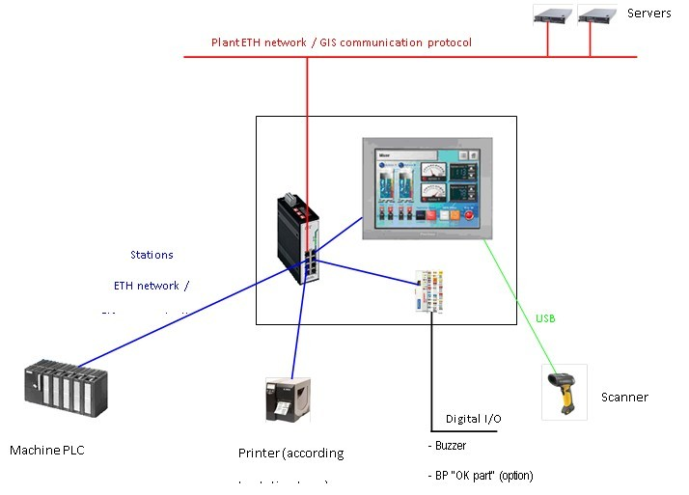

- PDE3 protocol between Ijcore and Proface.

- ISCP1, ISCP2, ISCP3 between Proface and PLC

PRO-FACE + PLC

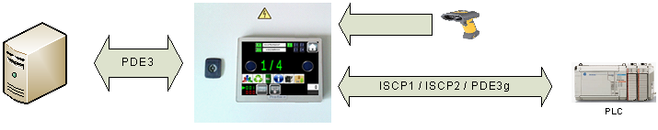

## PLC communication

- Communication and exchanges between IJcore and PLCs will depend on BG, process and machines.

- FAE : PDE3, ISCP1

- Normally, all PLCs models and products can be taken in account by OPC (currently Kepware).

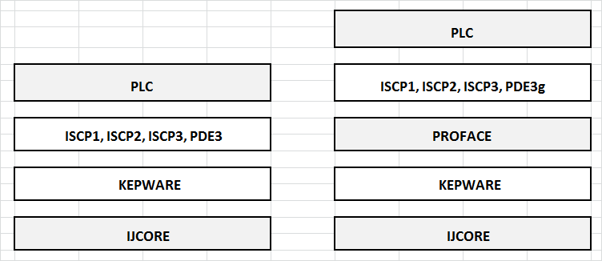

## Production and container labels

***Label Model 001***

Text: First line: part reference + plant

Barcode data on left board (centered): Part reference (1D barcode)

Third line: Operator + Date & time

Chengdu P84 TG Black EP MIOVENI

IU79LC

**OP123456 01/01/2014 12:55:00**

98263952TGyyddduuuu

Code content specification

98263952 : Customer part number

TG : Tailgate

yy: year

ddd: day

uuuu: daily counter

# Hardware architecture & Software

Hardware architecture is defined by 9TechShopfloor.

For each new project (new plant or existing plant), you need to review hardware and software with 9TechSF and CC Brazil.

It is based on 2 servers & VM, windows 2008 server and SQL 2008

Replication is done by Double Take

**Hardware description**



**Software description**



# Questionnaire for requirements

Project Information

Project name: Chengdu FAE P84

Plant: Chengdu FAE

Client: PSA

Description: P84

Main dates :

Deployment date: W34

MPTs: W31

SOP: 10.17